Clarification of data used in Lab 7.  
  
Hi everyone,

I want to offer a clearer walkthrough of the NLCD data used in Lab 7 to help you complete the assignment. I got turned around with the file myself, and I apologize for the confusion.

Please make sure to use the **highlighted layers** provided for this lab. These are the specific ones you'll need to complete the tasks.

Also, to make up for the confusion, I’m **waiving any late penalties** for this lab.

You need the highlighted layers for this lab:  
  
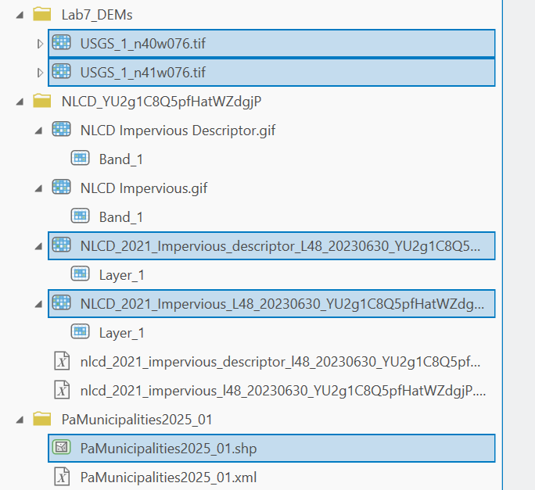  
  
This lab uses PA Municipalities, DEM grids, and a land cover classification. We are using a different dataset than the landcover 2016. This is because landcover 2016 is no longer available. The NLCD dataset we’re using is called NLCD_YU2g1C8Q5pfHatWZdgjP .zip and is posted on canvas. Unzip the folder and contents looks like this:  
  
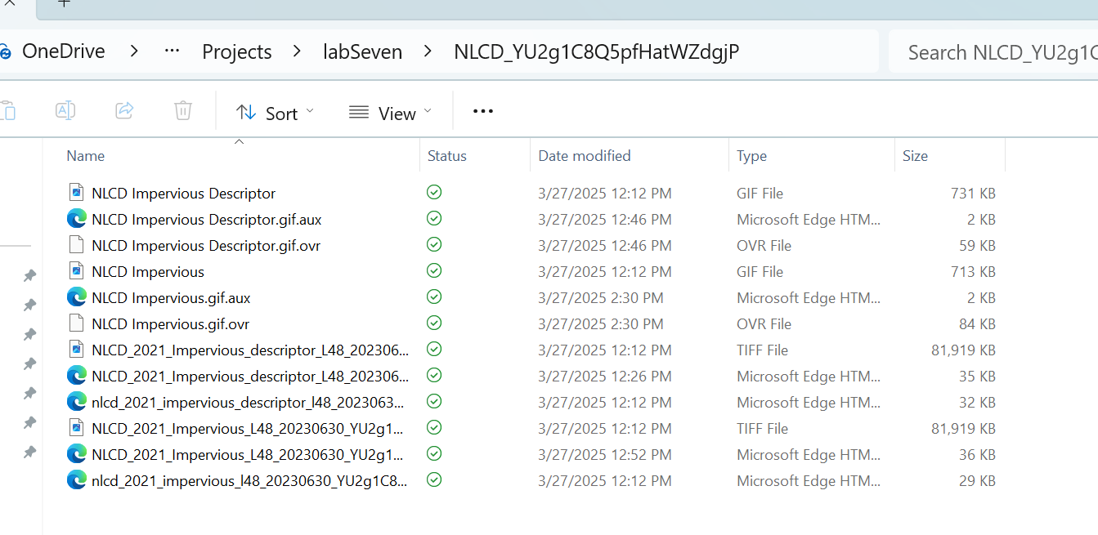

You’ll need **NLCD_2021_Impervious_descriptor_L48_20230630_YU2g1C8Q5pfHatWZdgjP.tiff** for the tutorial, and **NLCD_2021_Impervious_L48_20230630_YU2g1C8Q5pfHatWZdgjP.tiff** for the assignment,

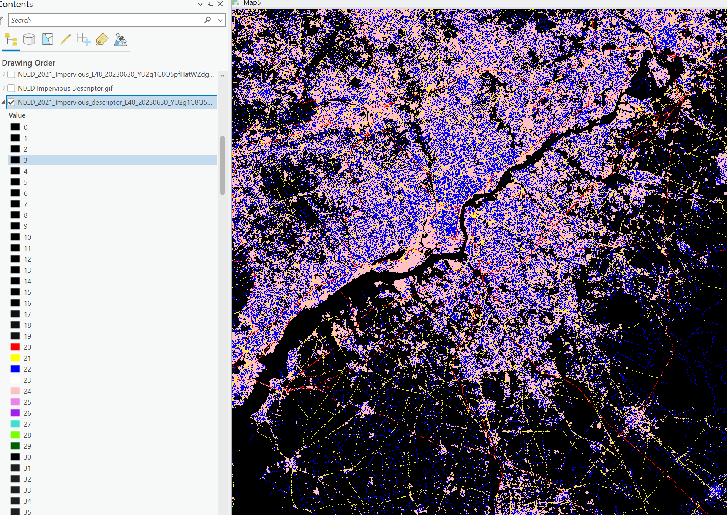

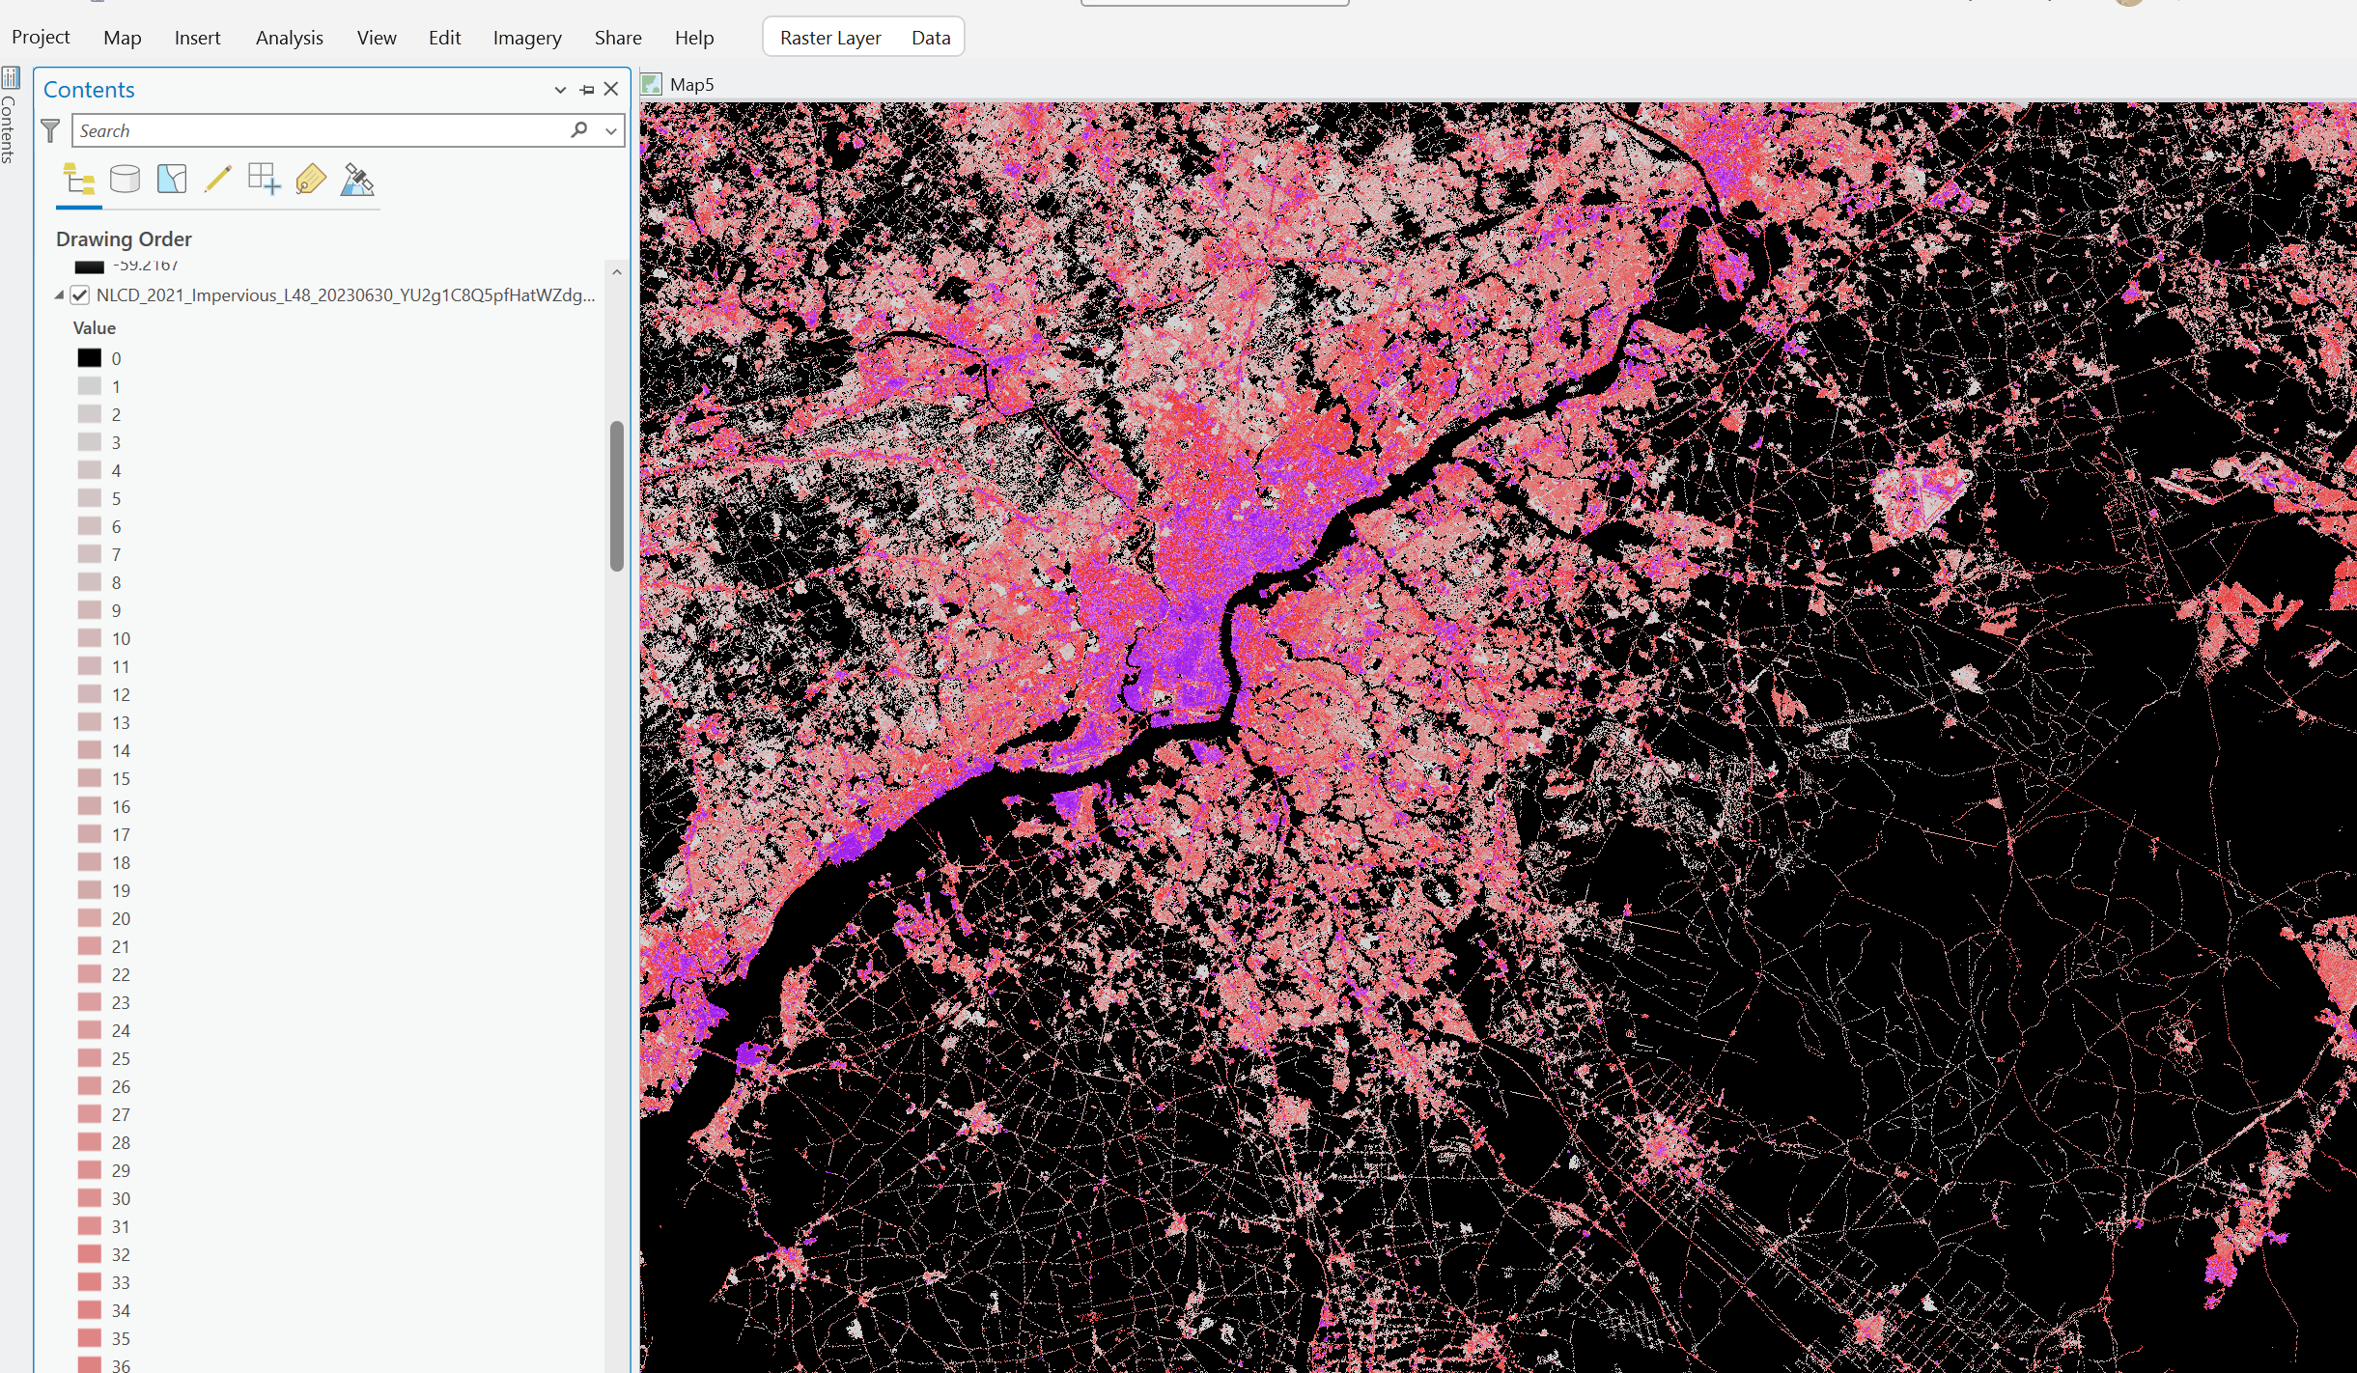

In the tutorial, extract by mask leaves you and these values only: 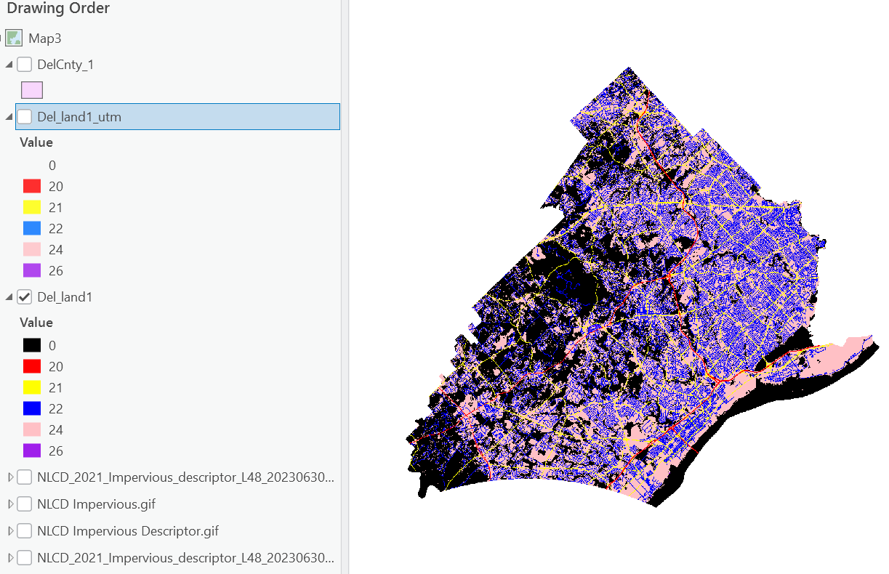

Which correspond to these land uses:  
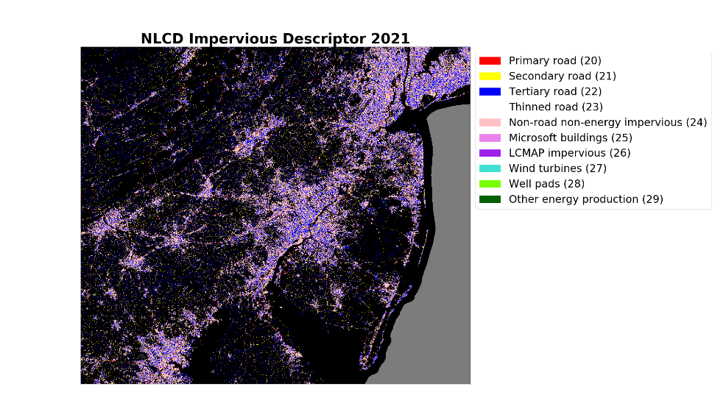Change the projection by using the **Project Raster** tool.   
  
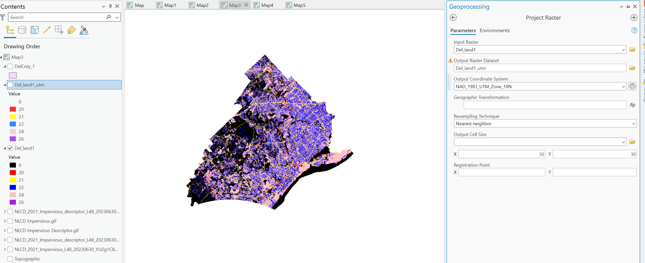

Set the 0 value to no color. The remaining are your developed zones. Change transparency, play around with color schemes.  
  
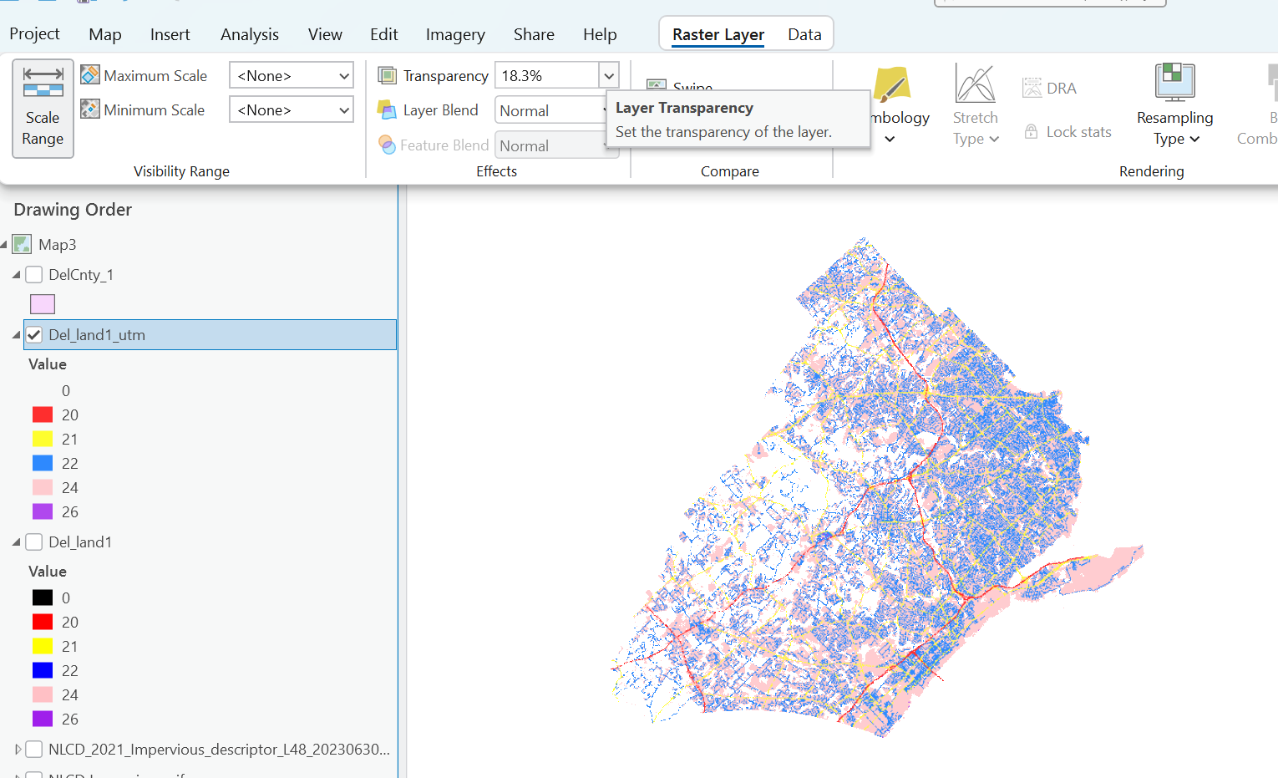

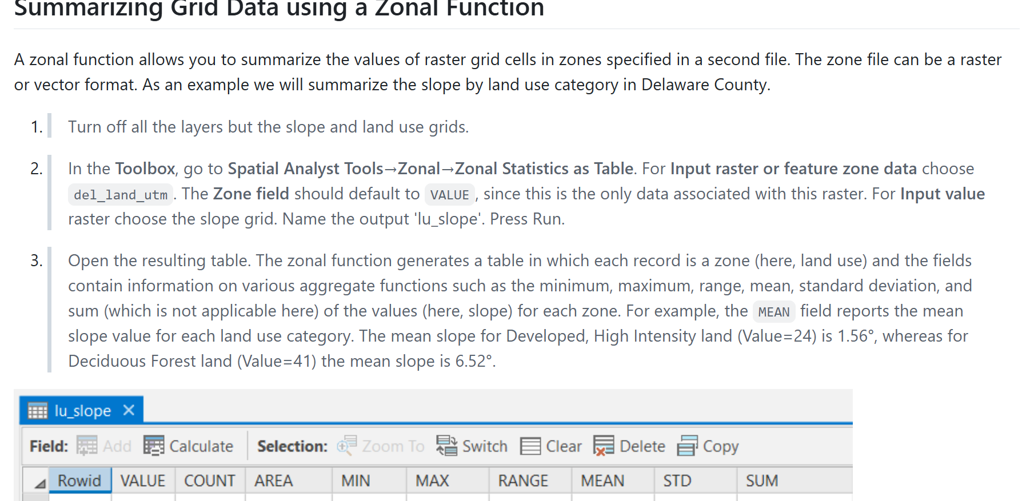

Zonal Statistics for each land use category. Use Municipalities as zone data and slope as value raster.  
  
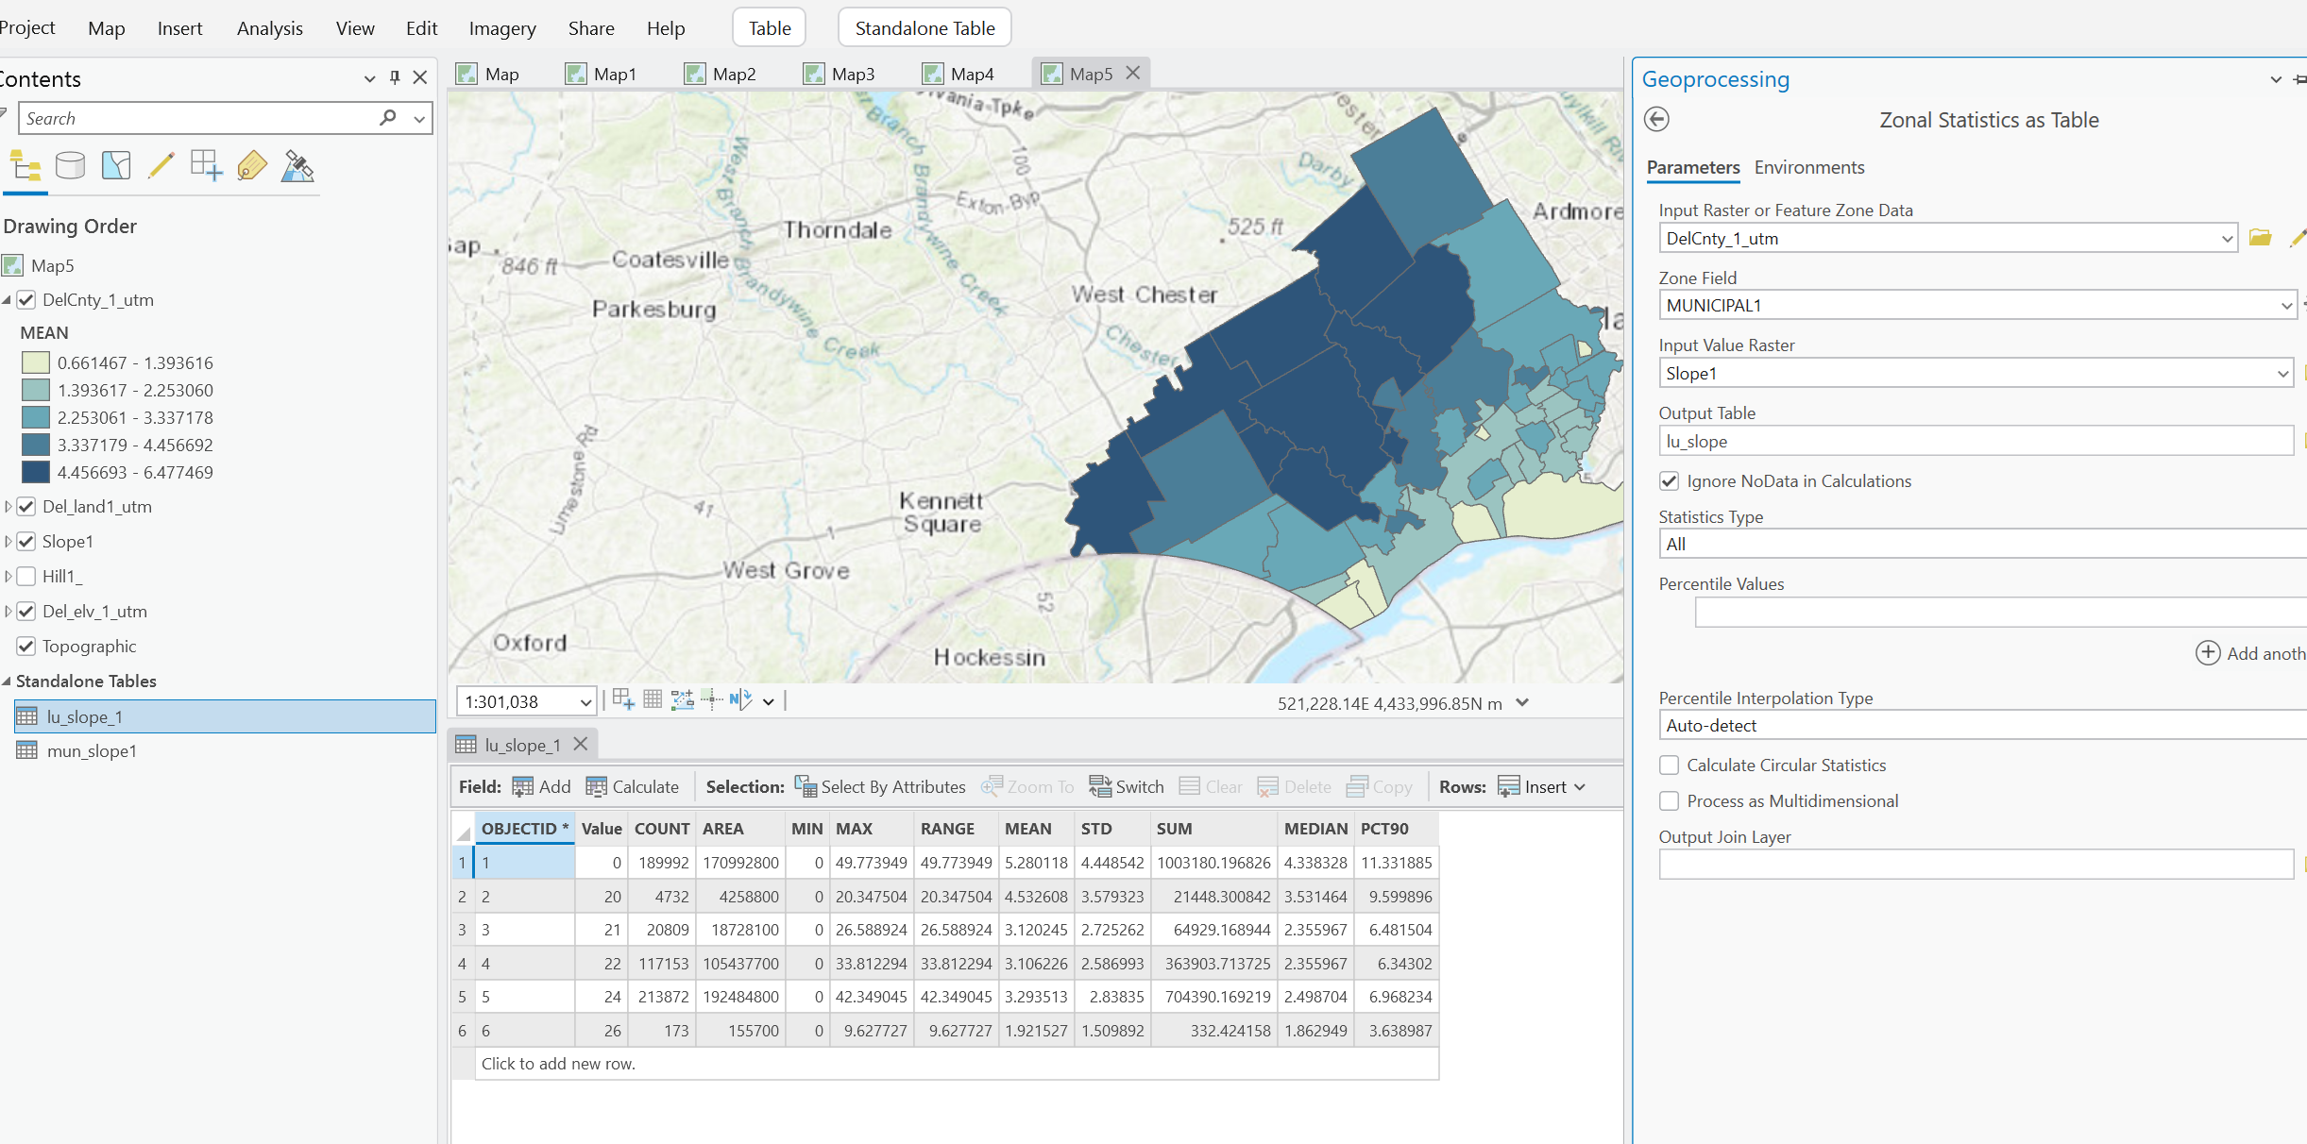  
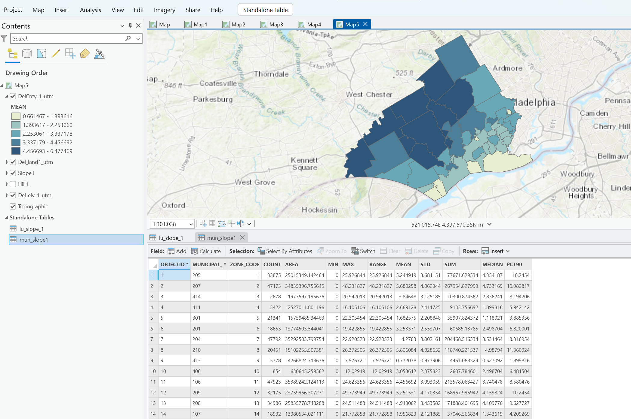

Assignment:  
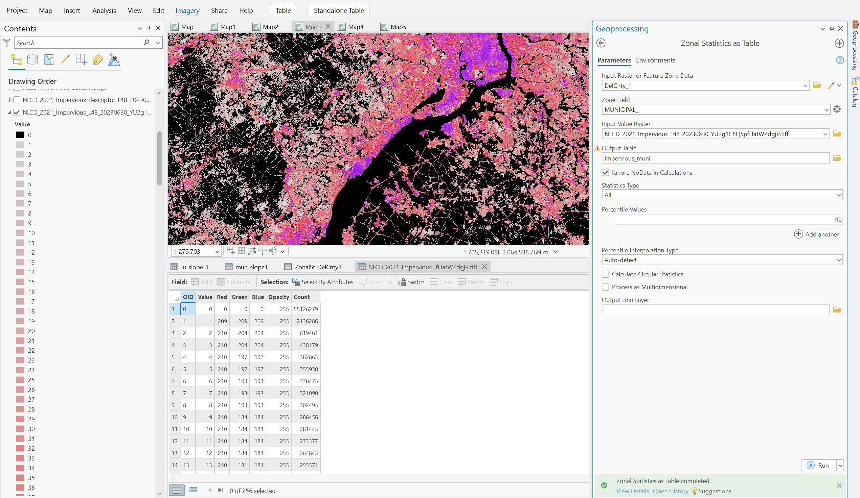

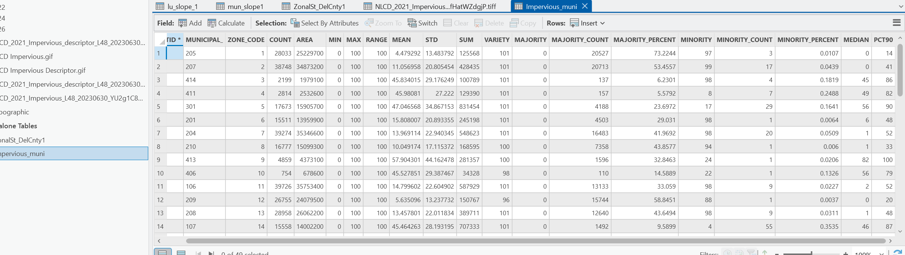  
  
Look at the **MEDIAN** field

* This tells you the **median impervious %** per municipality.
* Example: MEDIAN = 52.6 means half the area is **≥ 52.6% impervious**

**Select municipalities where MEDIAN ≥ 50**